Installation of Softwares required for successful running of CAST

1. Installation of Github Desktop

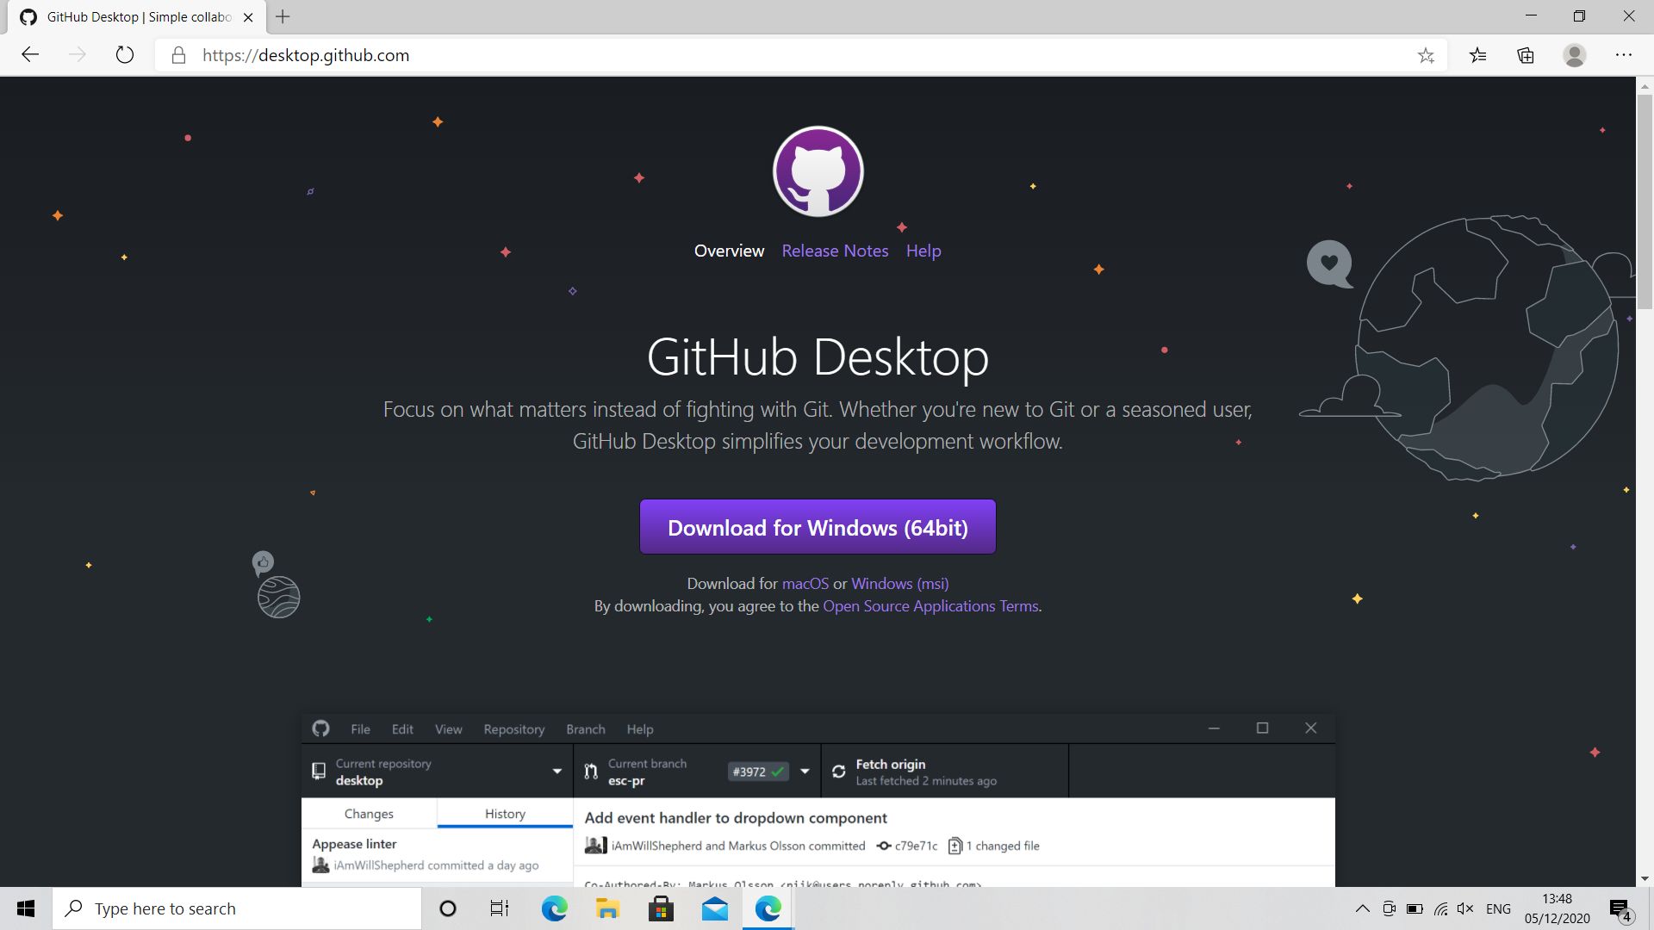

After successful installation of Github Desktop, open the Github Desktop Application and click on clone a repository. Under URL, paste the URL as seen below. This can also be alternately seen under [CAST-IIT/CAST at Personal-CAST-development (github.com)](https://github.com/CAST-IIT/CAST/tree/Personal-CAST-development), under ‘Code’. **[Please note Personal CAST is the default branch/master branch]**

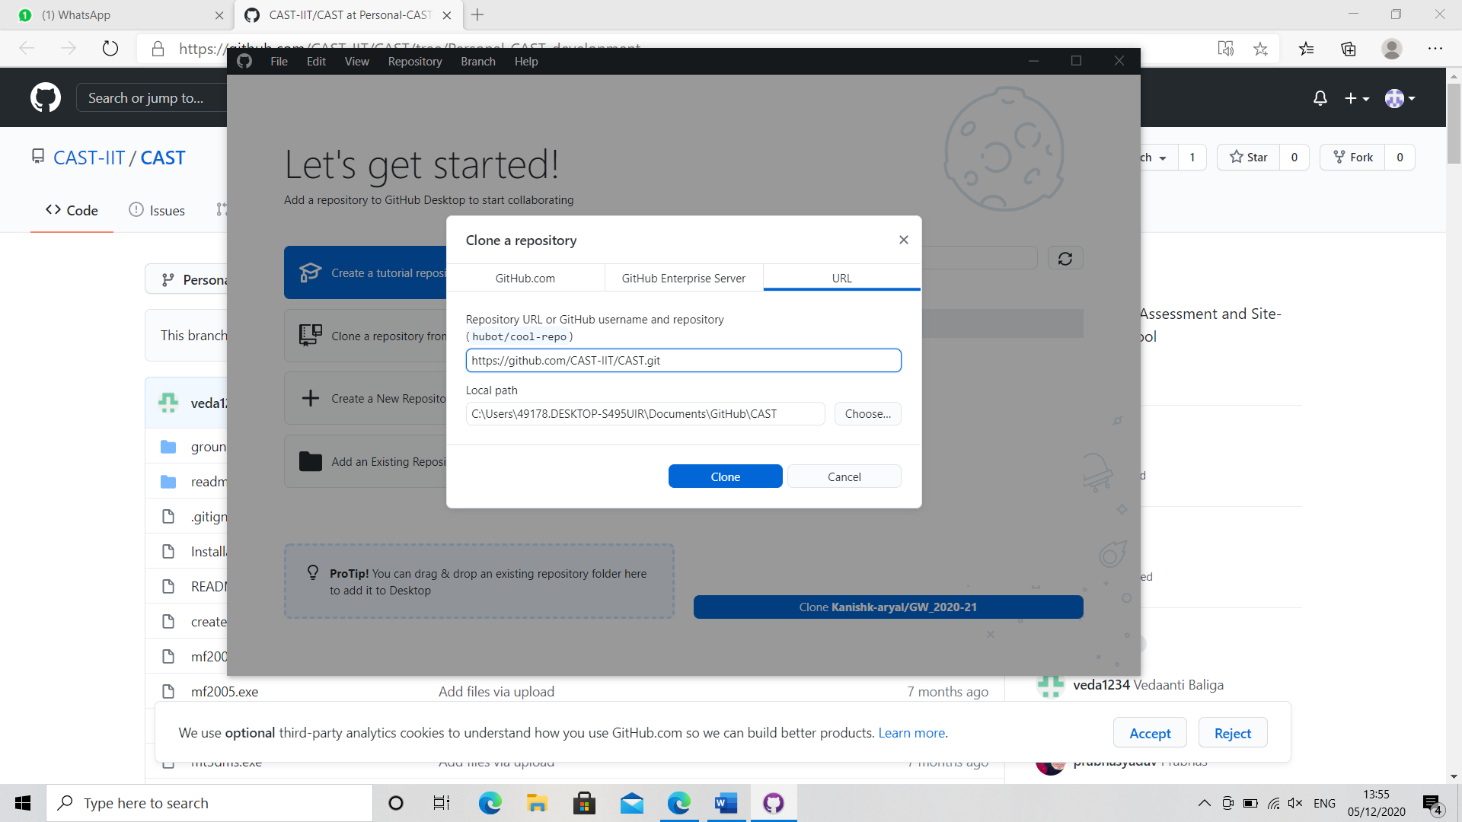

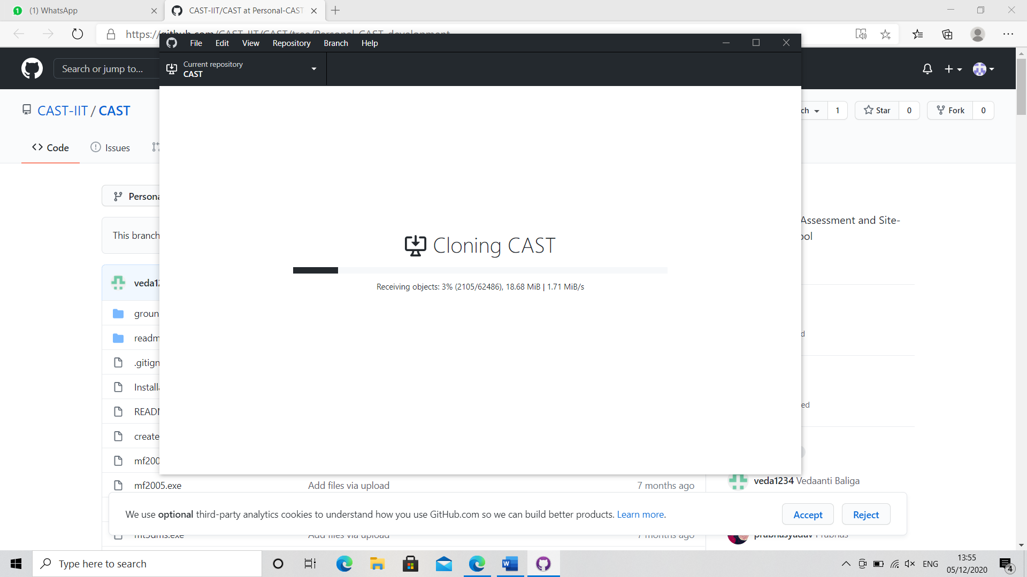

1. Installation of Python: From the website ‘ <https://www.python.org/downloads/> ’, download version **3.6.8** of Python. Click on the file version which is suitable for your Operating system.

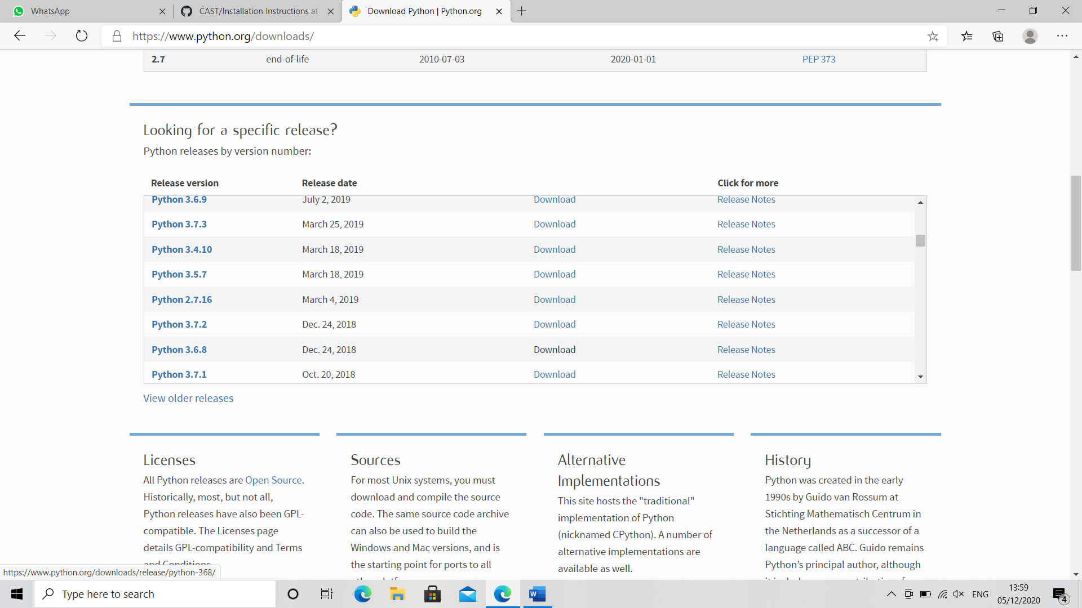

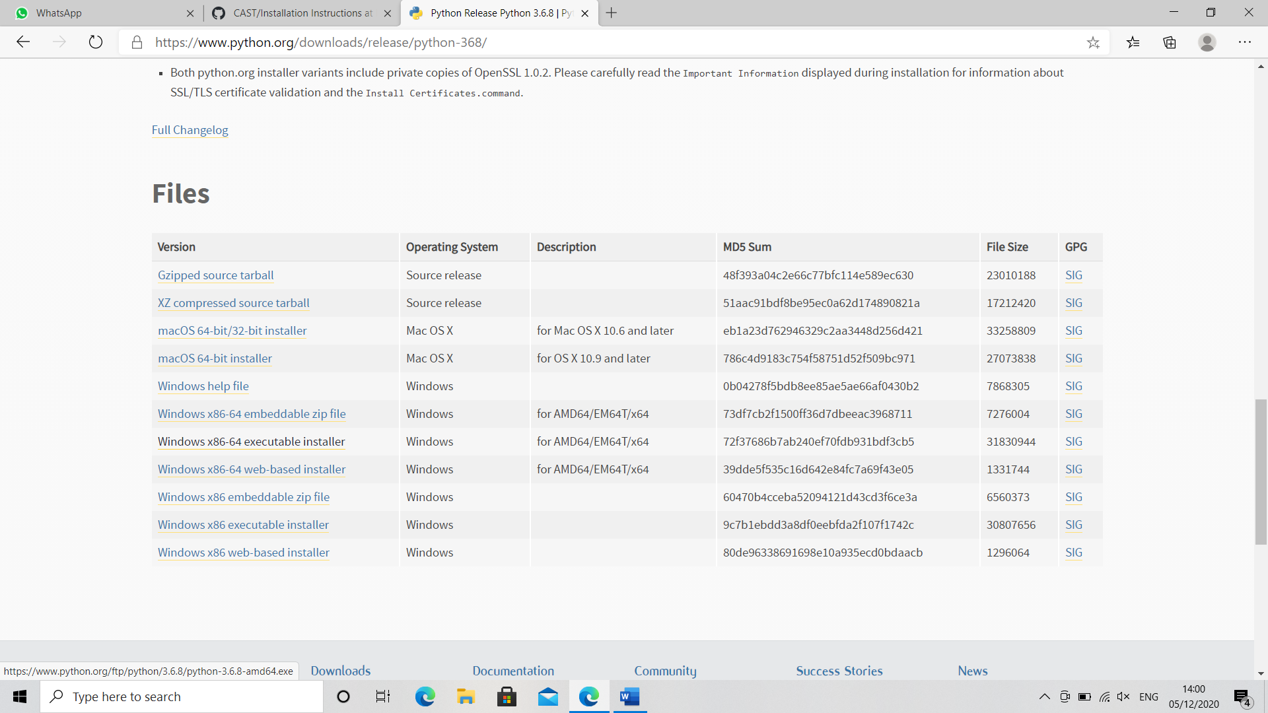

1. Open the executable file, and click on Install now Button. Do not forget to check the box that says ‘**Add Python 3.6 to Path’**.

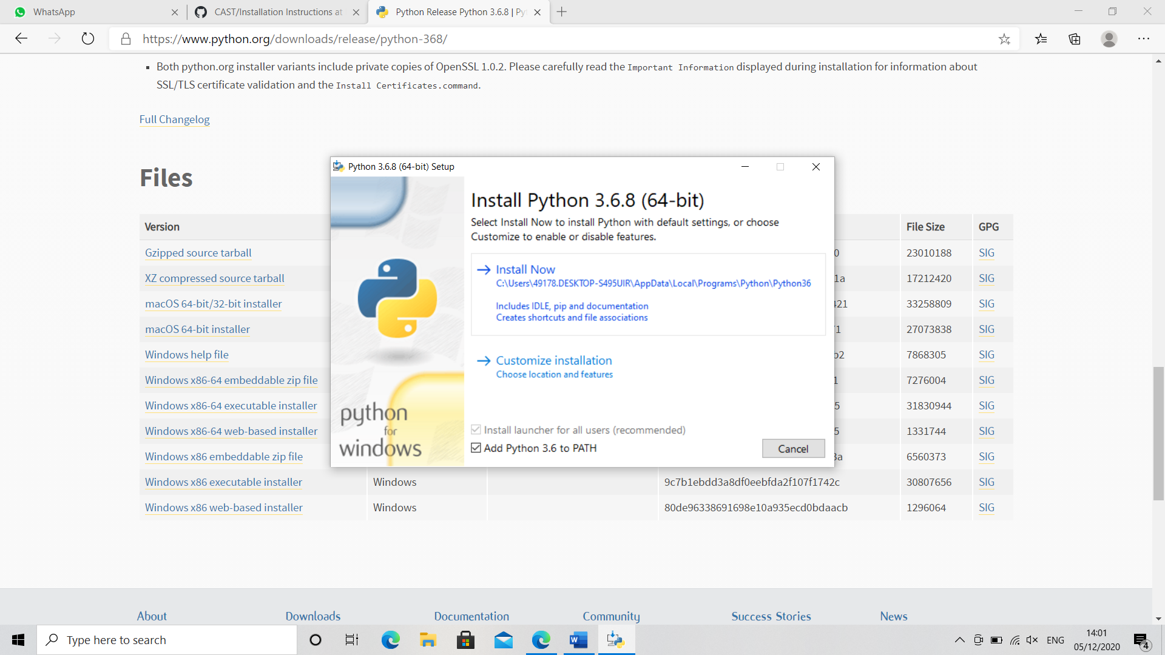

1. After the setup is successful, it is a mandatory step to check if pip is also installed and for the version of Python, we go to the Command Prompt.

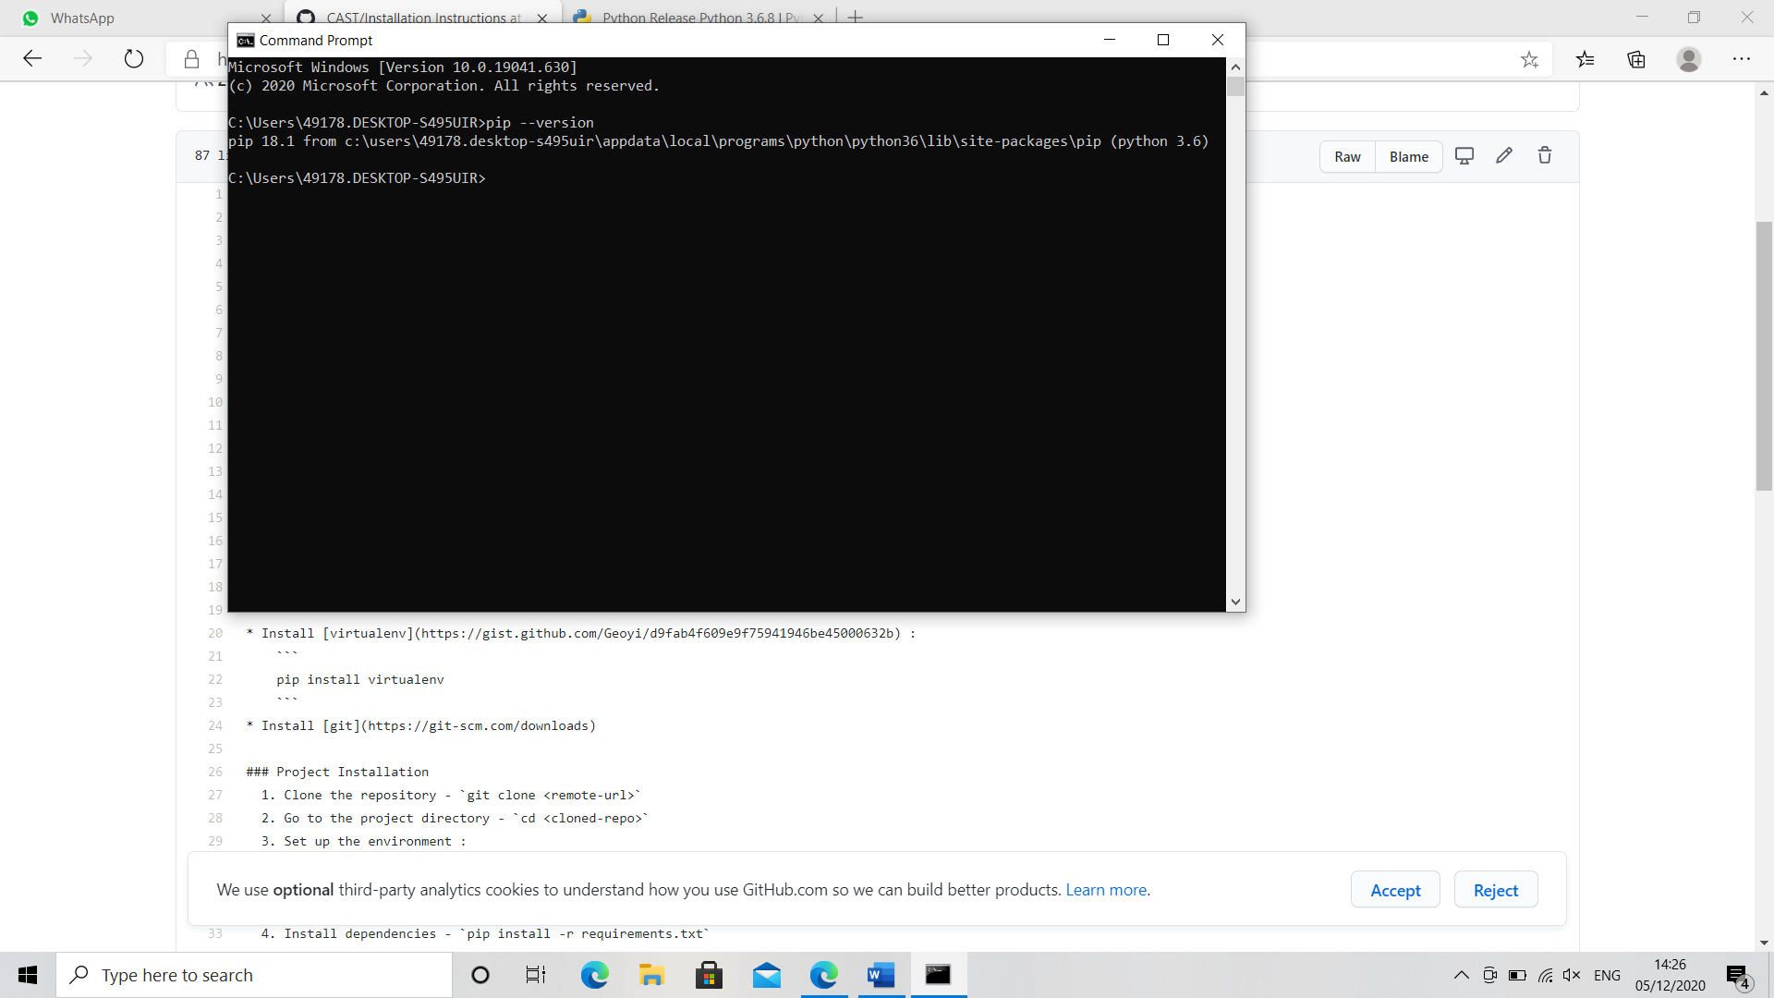

1. Incase no pip version is found, we can install it through command prompt by entering this line of command- ‘**python get-pip.py’.**
2. Additionally, to verify the version of python, we can see it through the following line of command.

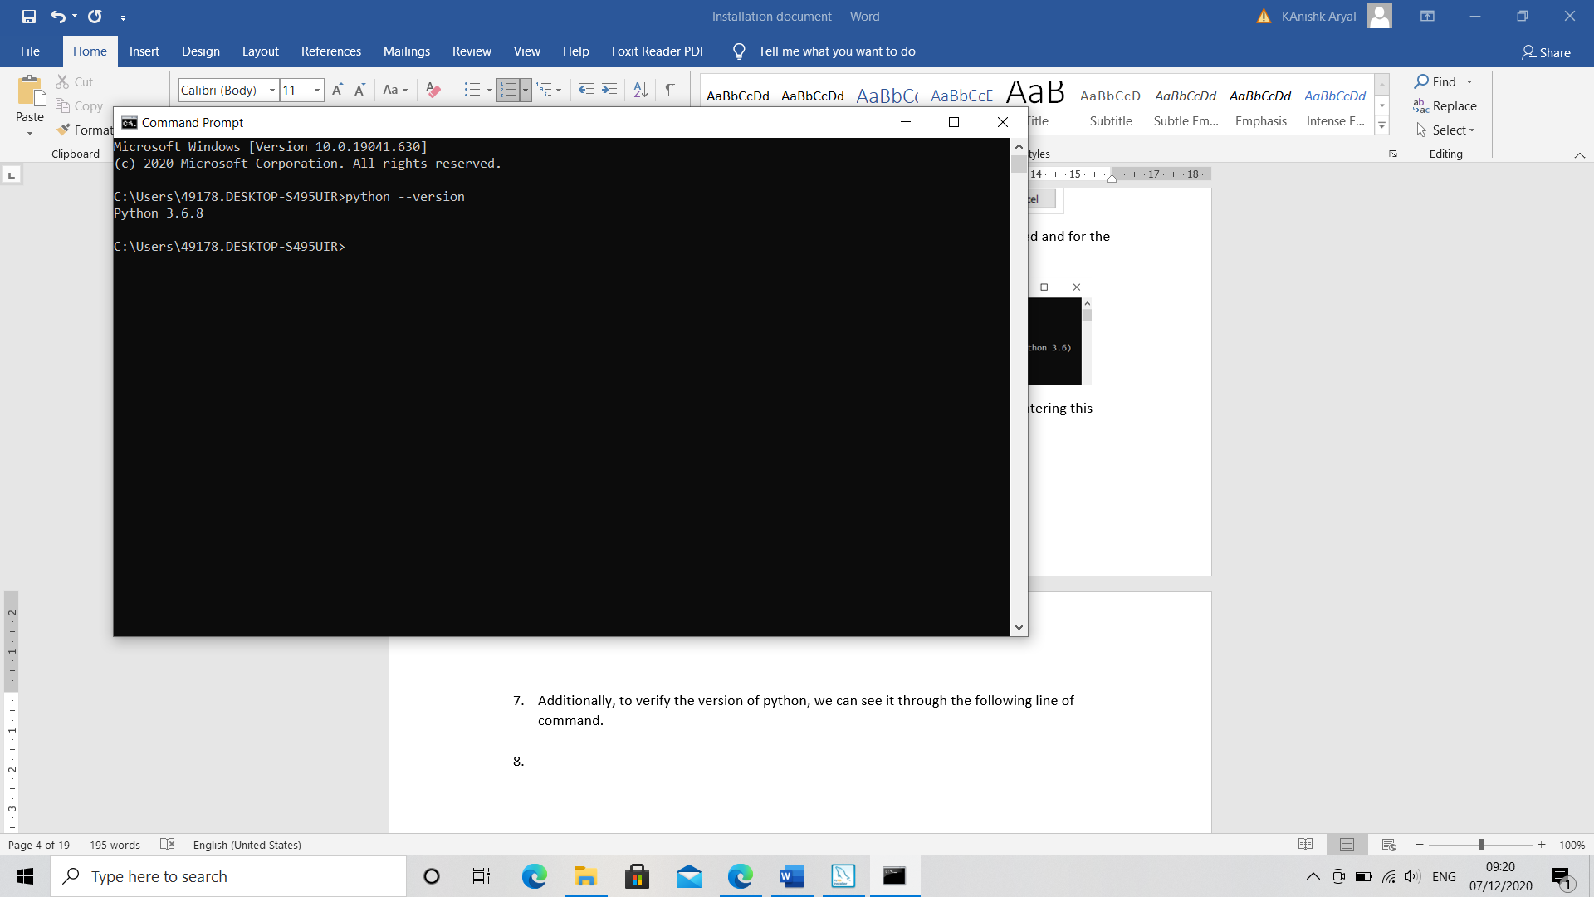

1. Installation of virtual environment.

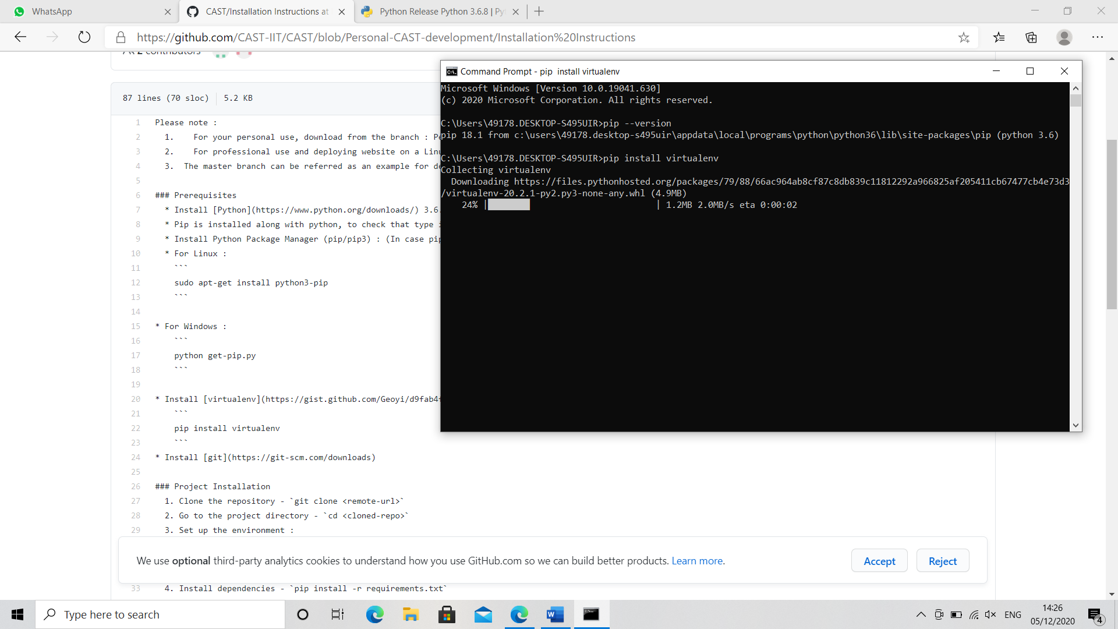

1. Create virtual Environment Files

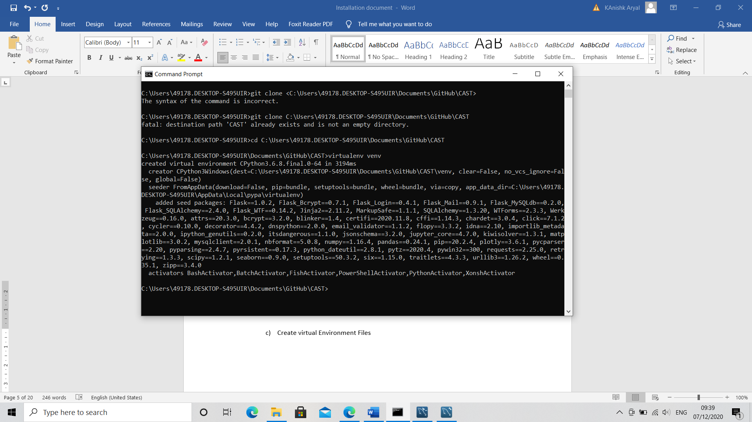

1. Activation: (it is complete when you see a **(venv)** before the command line)

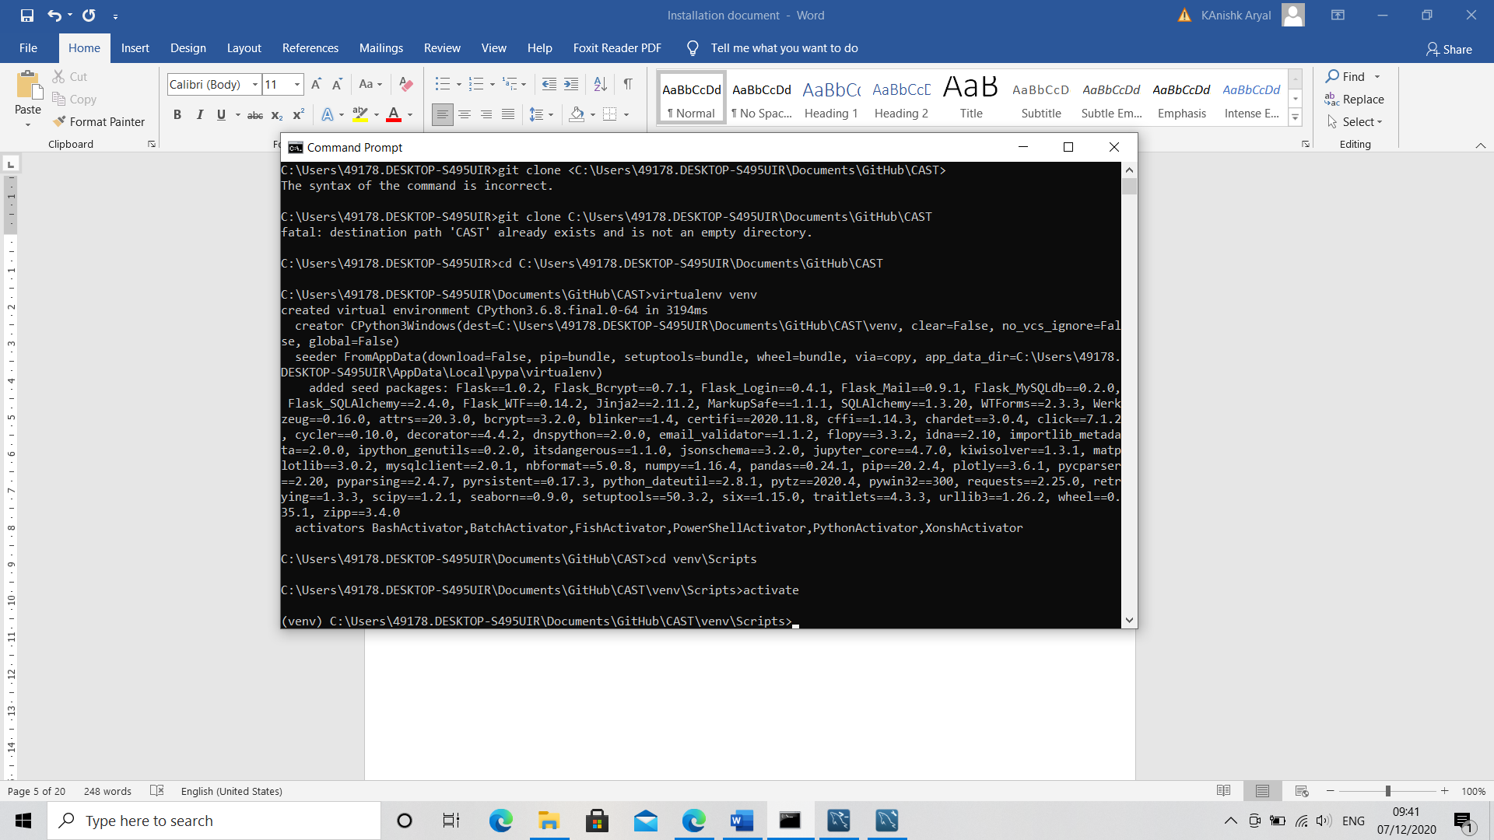

1. Get to the previous directory

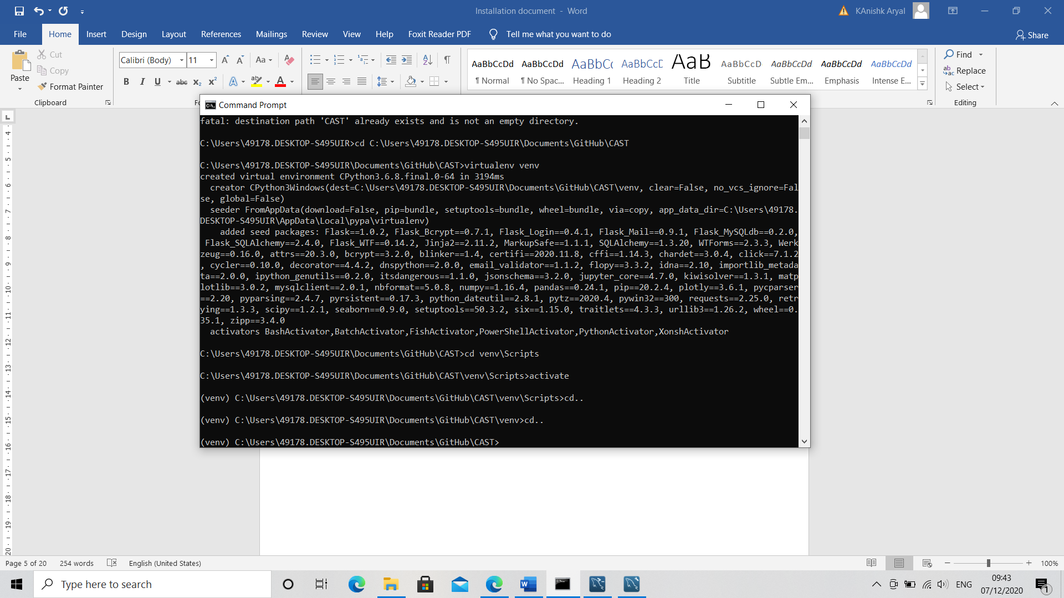

1. Installation of dependencies (do not close this command line)

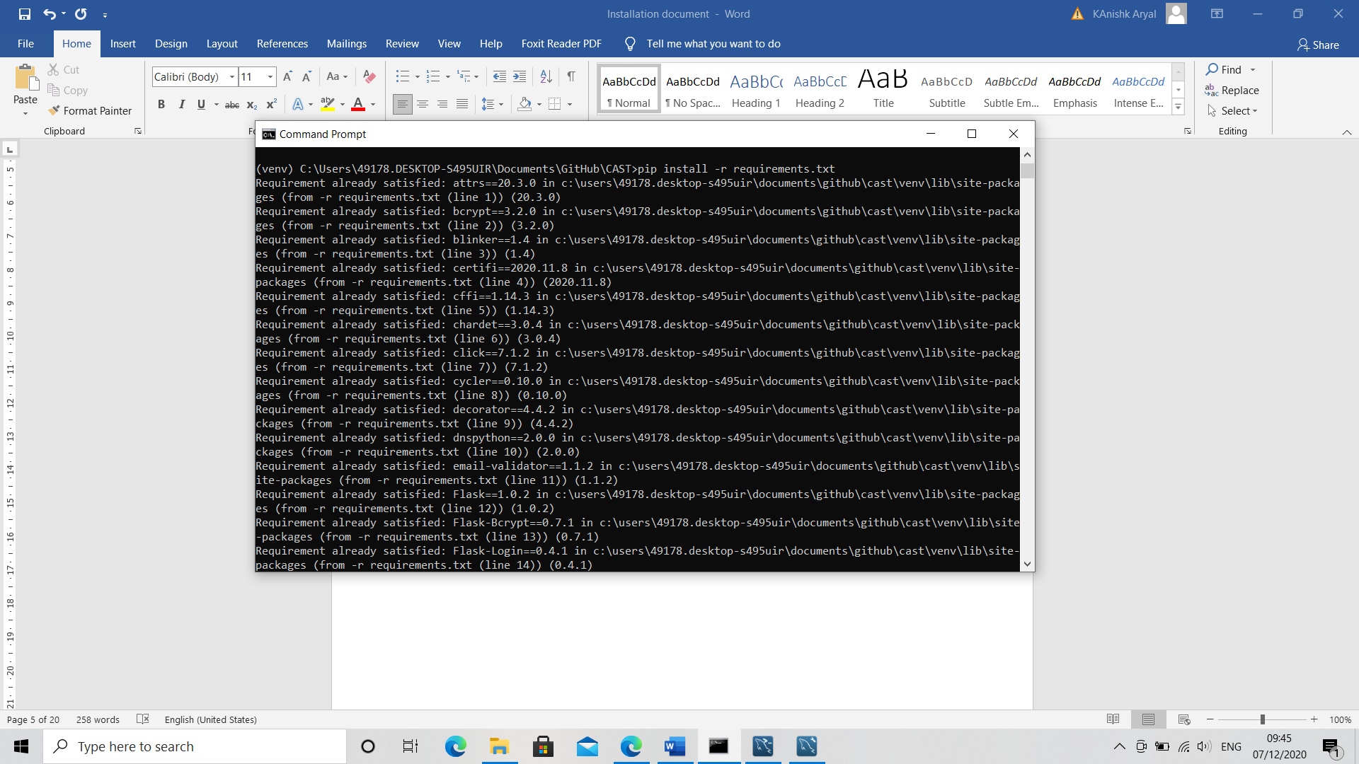

1. MySql Setup
2. Visit the webpage to download the installer file ‘ <http://dev.mysql.com/downloads/installer/> ‘
3. In the webpage, download the file that is about **400mb (the offline version)** in size and start the setup.
4. Choosing a Setup type

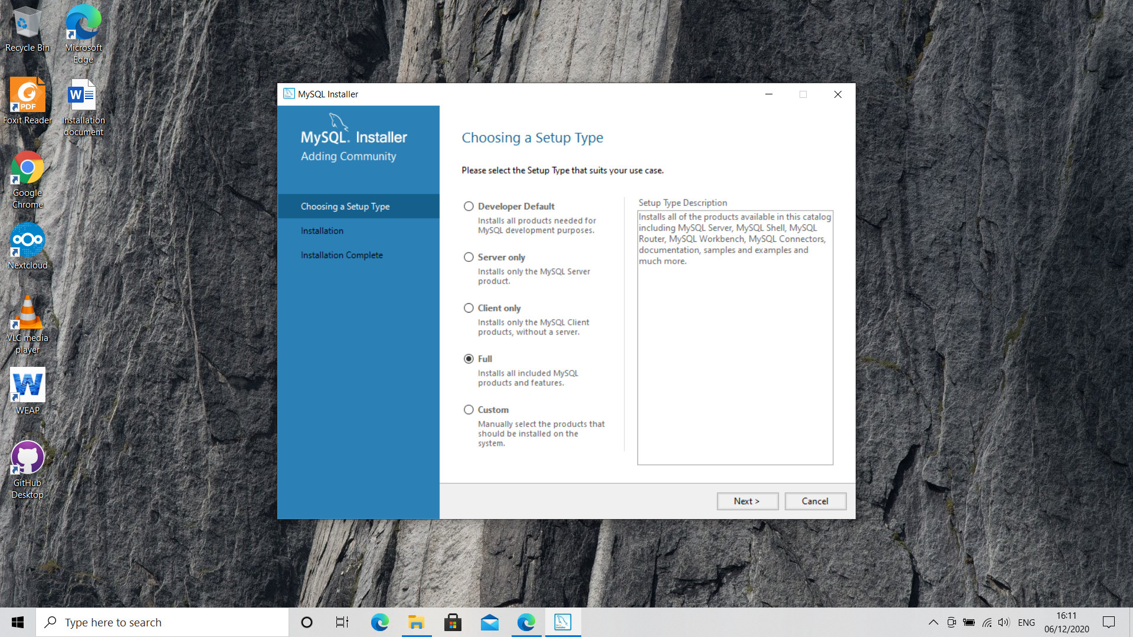

1. Keep on going to the next steps by simply clicking next or execute. Please do not skip any steps though.

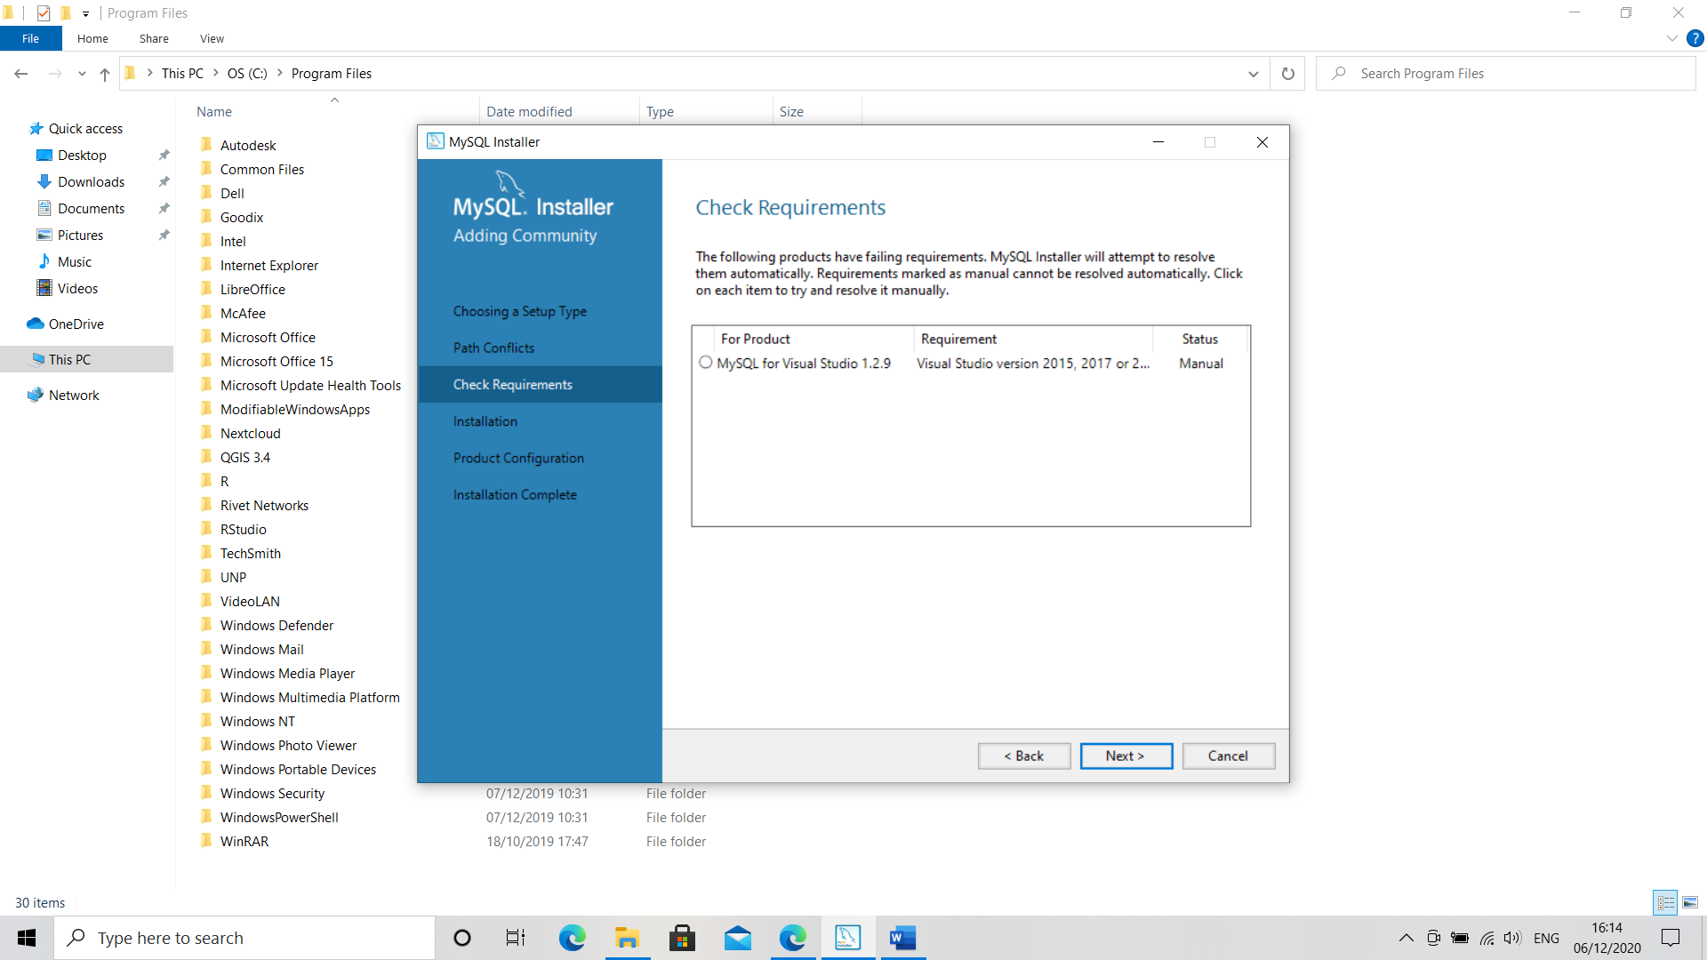

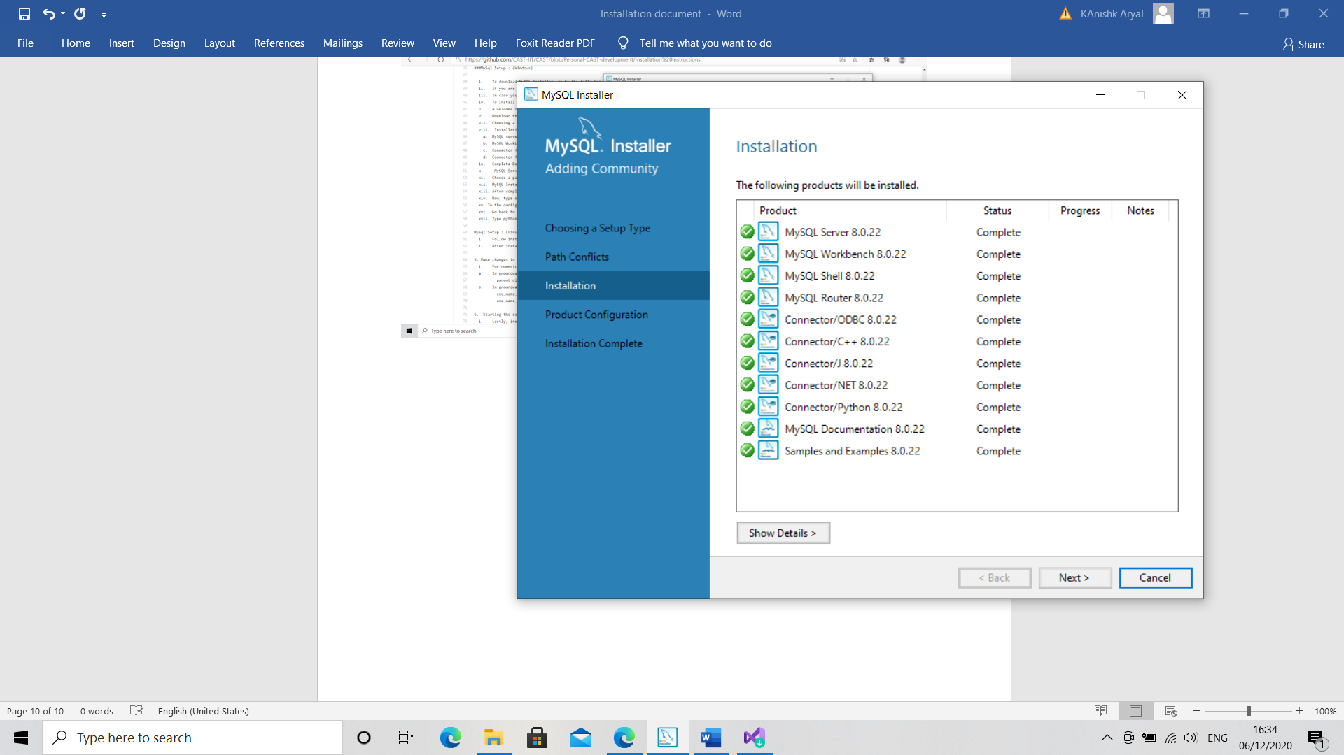

1. Keep every option as is it and continue until the account setting screen is obtained. Be sure to remember this password as in the next few steps, during application of configuration, we can check for the password if it is correct or not. Not to worry if it is weak.

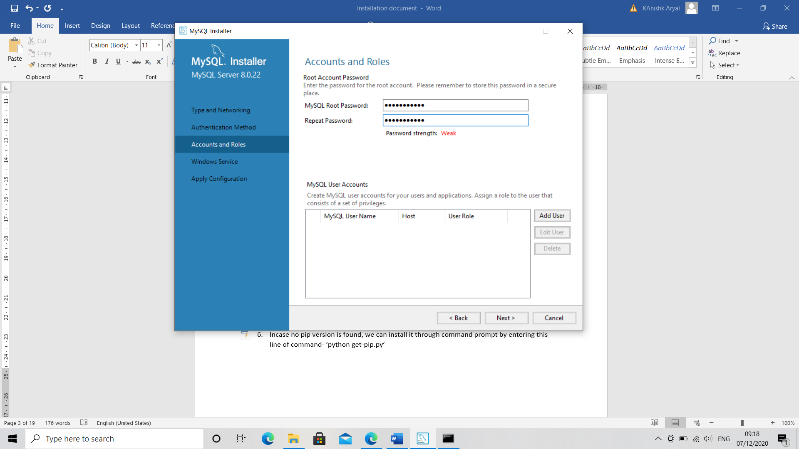

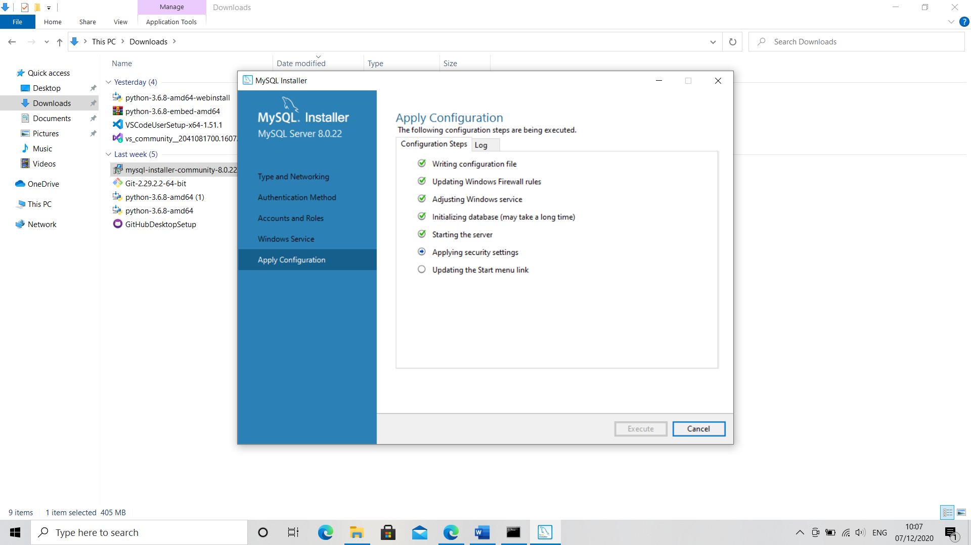

1. Insert the password that has been created before and **click on check**. Then can go to the next step.

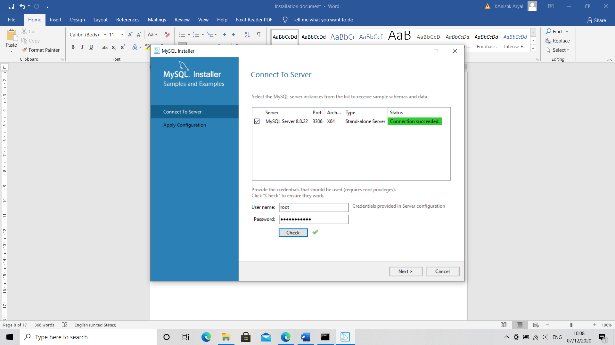

1. After installation, you can open the MySql software. Click on Connections and when asked, enter the **password** created during the setup.

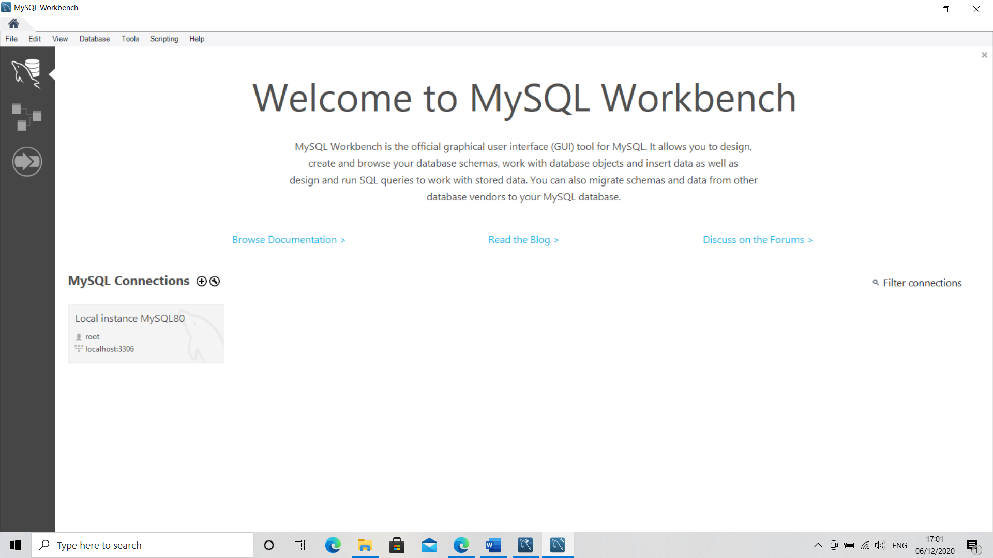

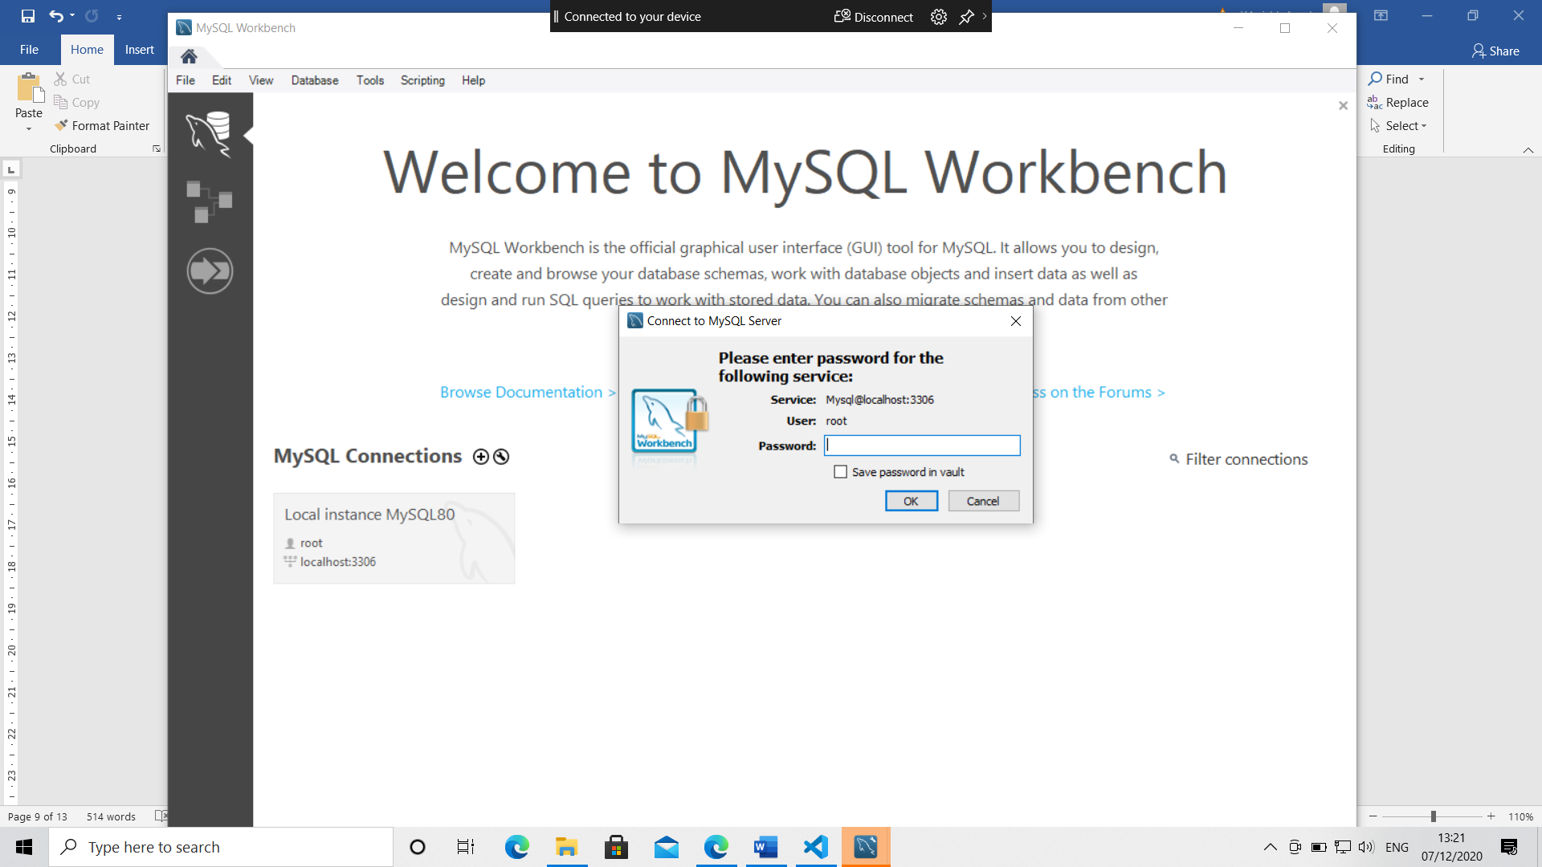

1. Create a database named groundwater in the new page. ‘**create database groundwater’**. Click on the ‘**lightning button**’ (It is used to execute), and wait until action is shown in the bottom.

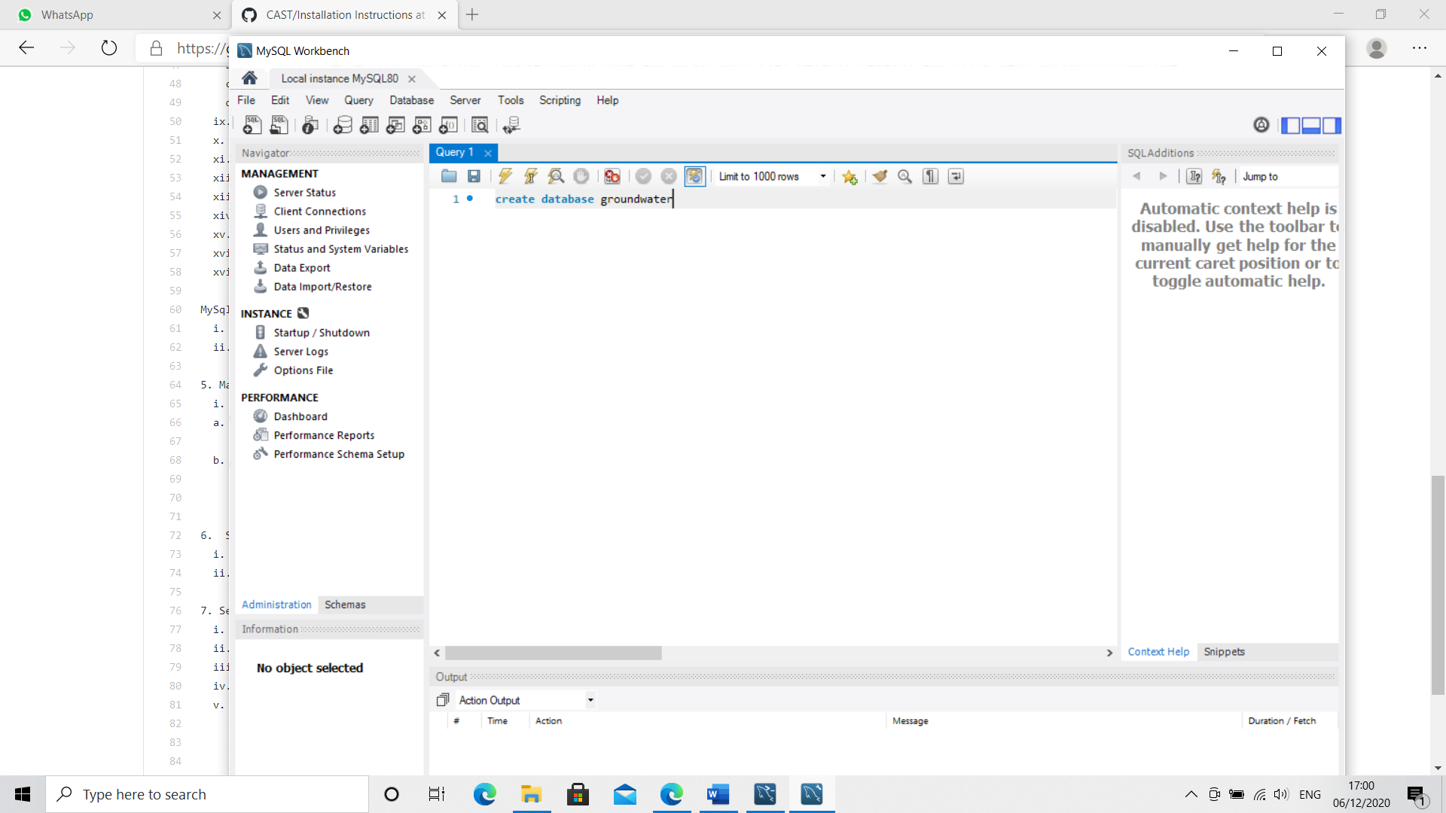

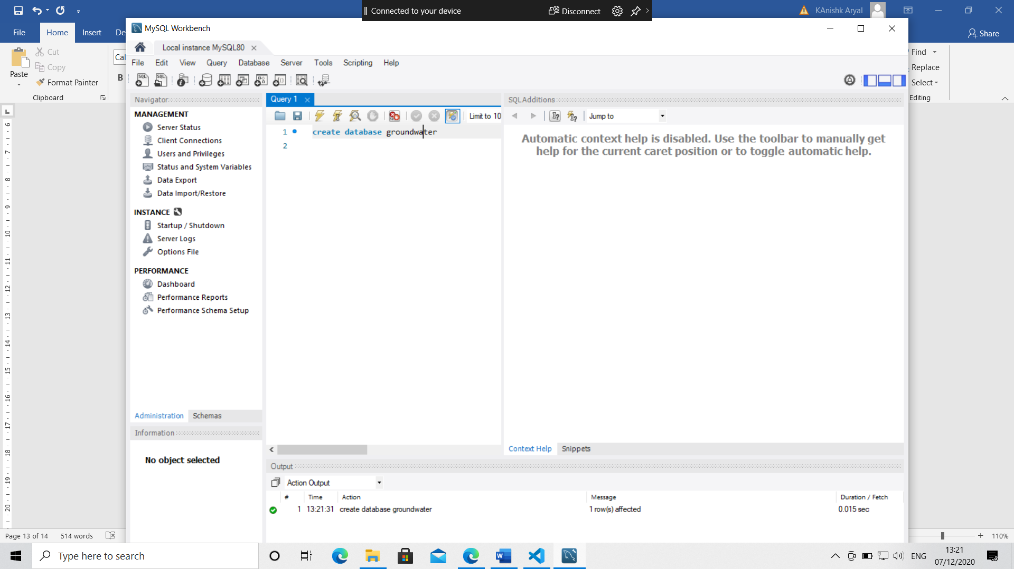

1. Now populate your database with the command (python3create_database.py or py create_database.py) shown below in the command line that we kept open in step 7.d



1. In Window’s system, don’t forget to do this before you activate your project :

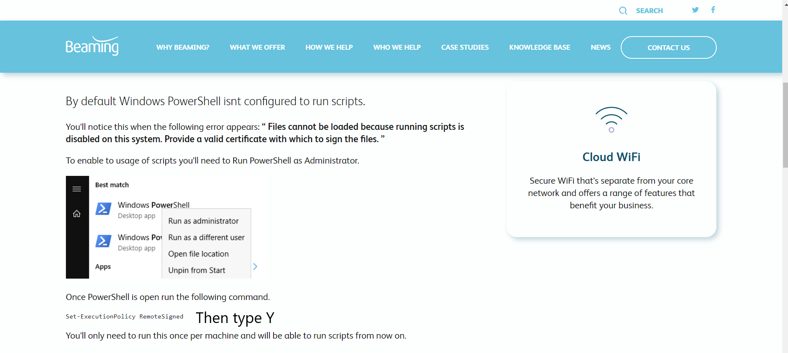

Reference : <https://www.beaming.co.uk/knowledge-base/resolved-files-cannot-loaded-running-scripts-disabled-system/>

1. In Visual Studio Code, open the file location; here select **CAST** and click on **Select Folder**. (Note: it is not a compulsion to run via Visual Code, there are other softwares like Pycharm which can also be alternately used. You can also simply run via the command line as well).

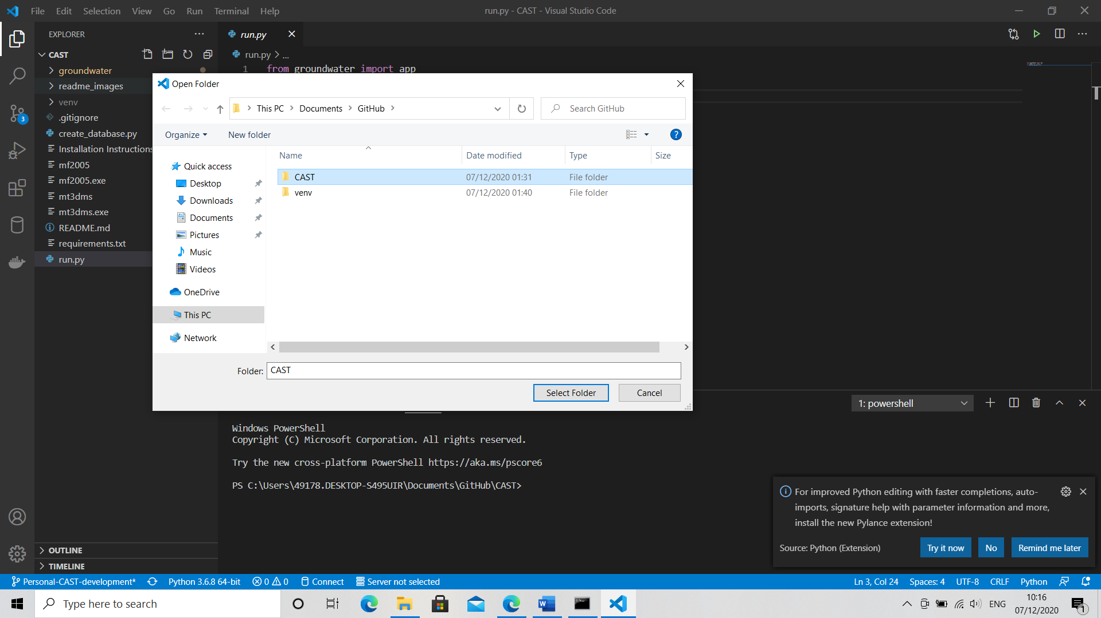

1. Under **groundwater>config.py**, change the password to your password used before during the setup .

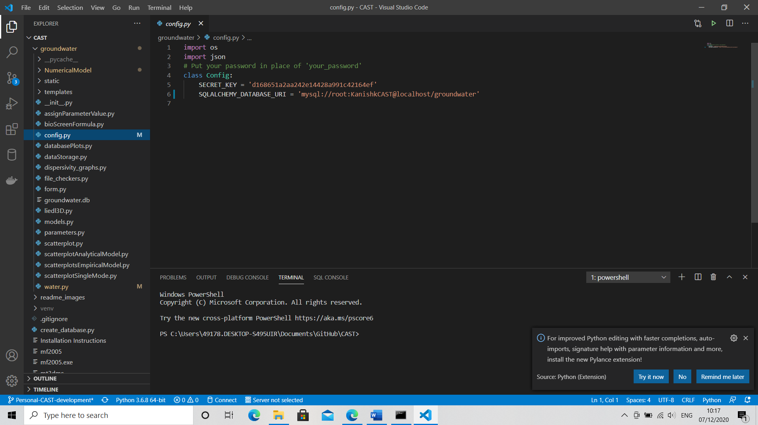

1. Under **groundwater/water.py**, change the **parent_dir= ‘your directory\\CAST’**

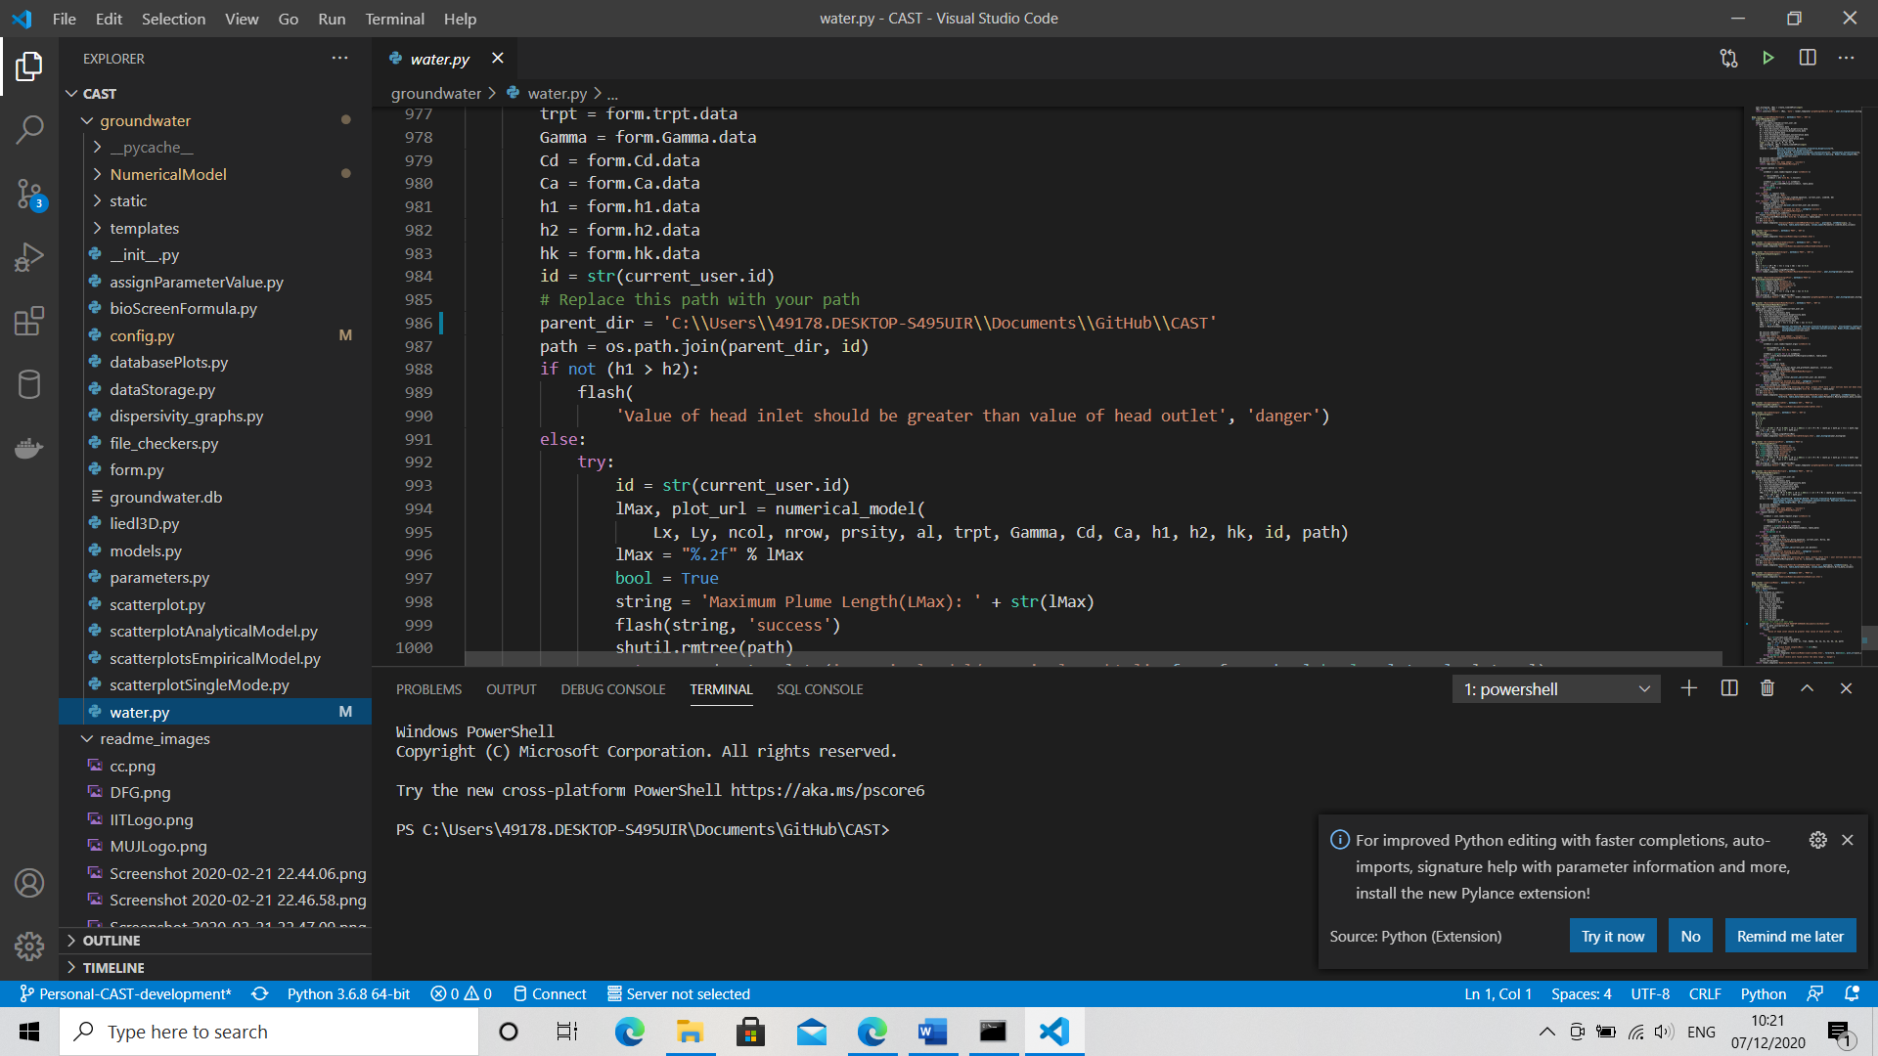

1. Under **groundwater/NumericalModel/numericalModel.py** change the following:

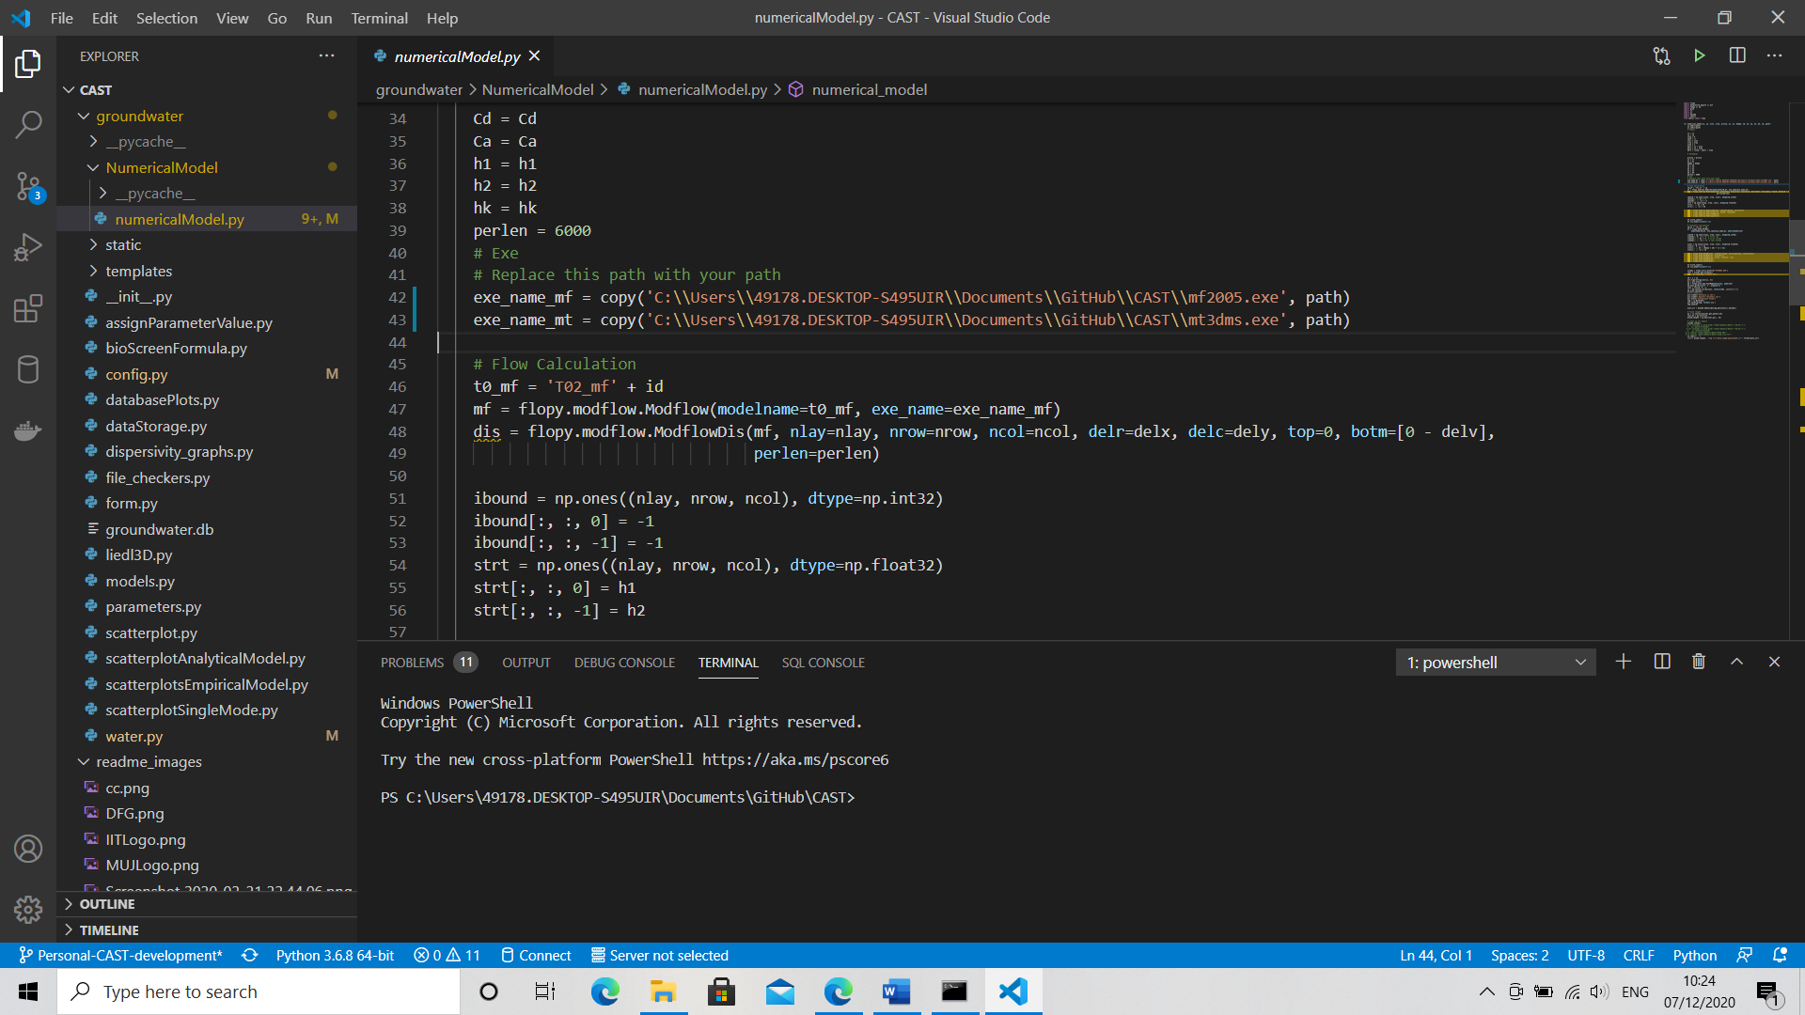

1. Click on the interpreter below and select the python interpreter -> virtual environment that you want to work in



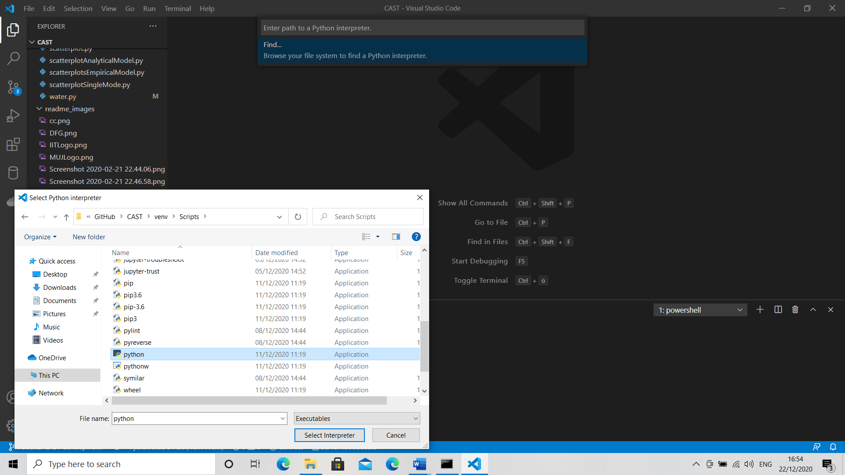

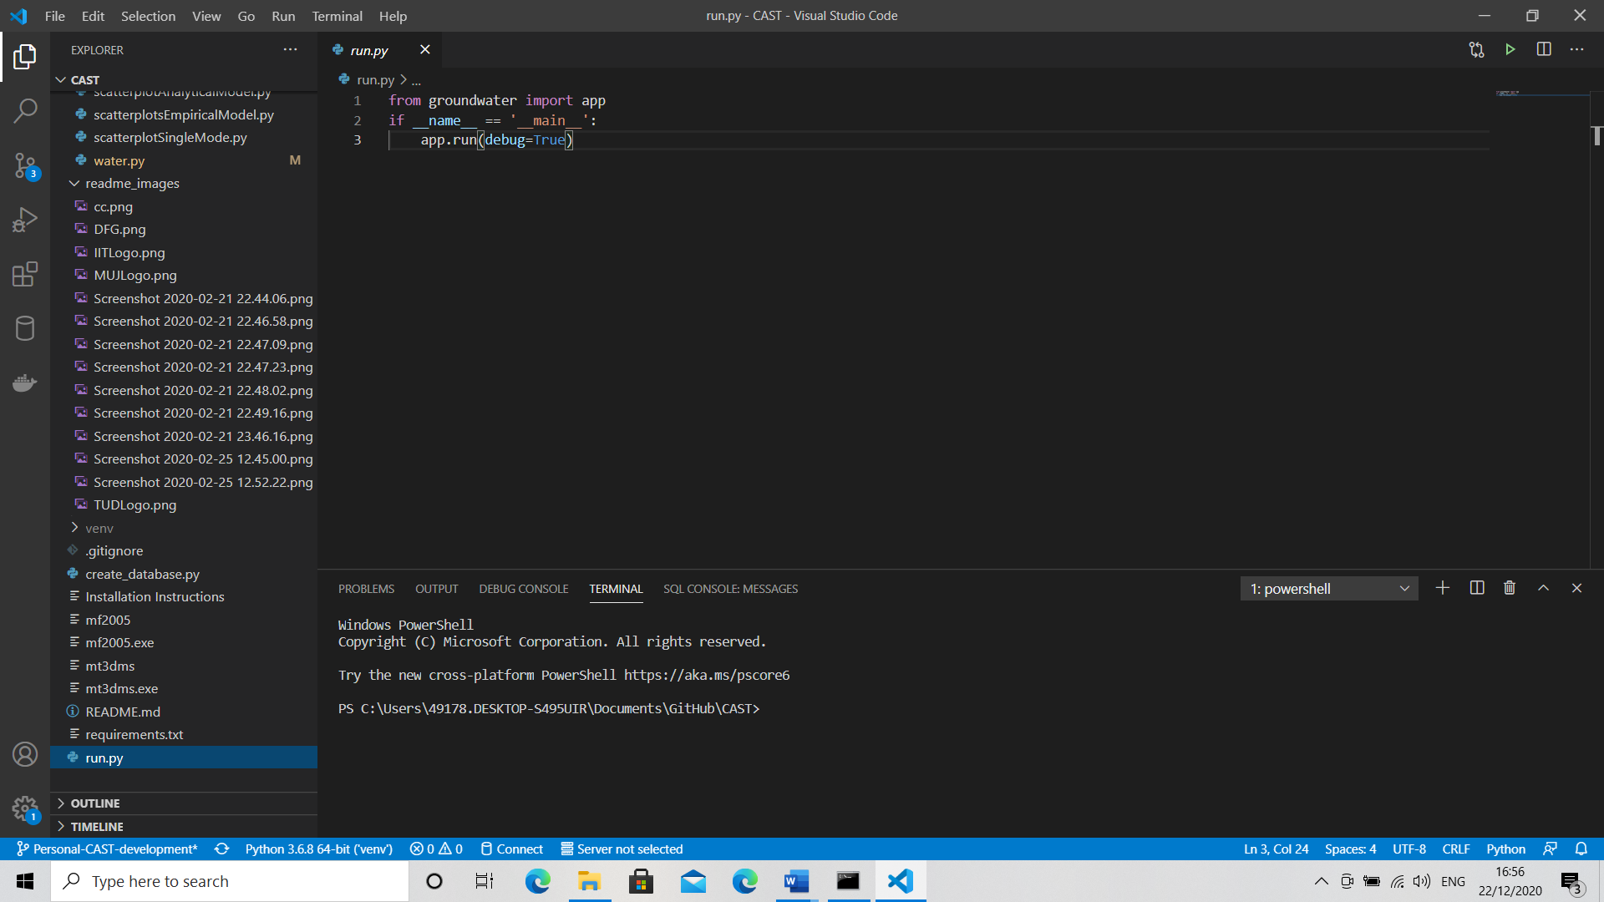

1. Go to **run.py** and on the top right corner click on the **green play button** to run.

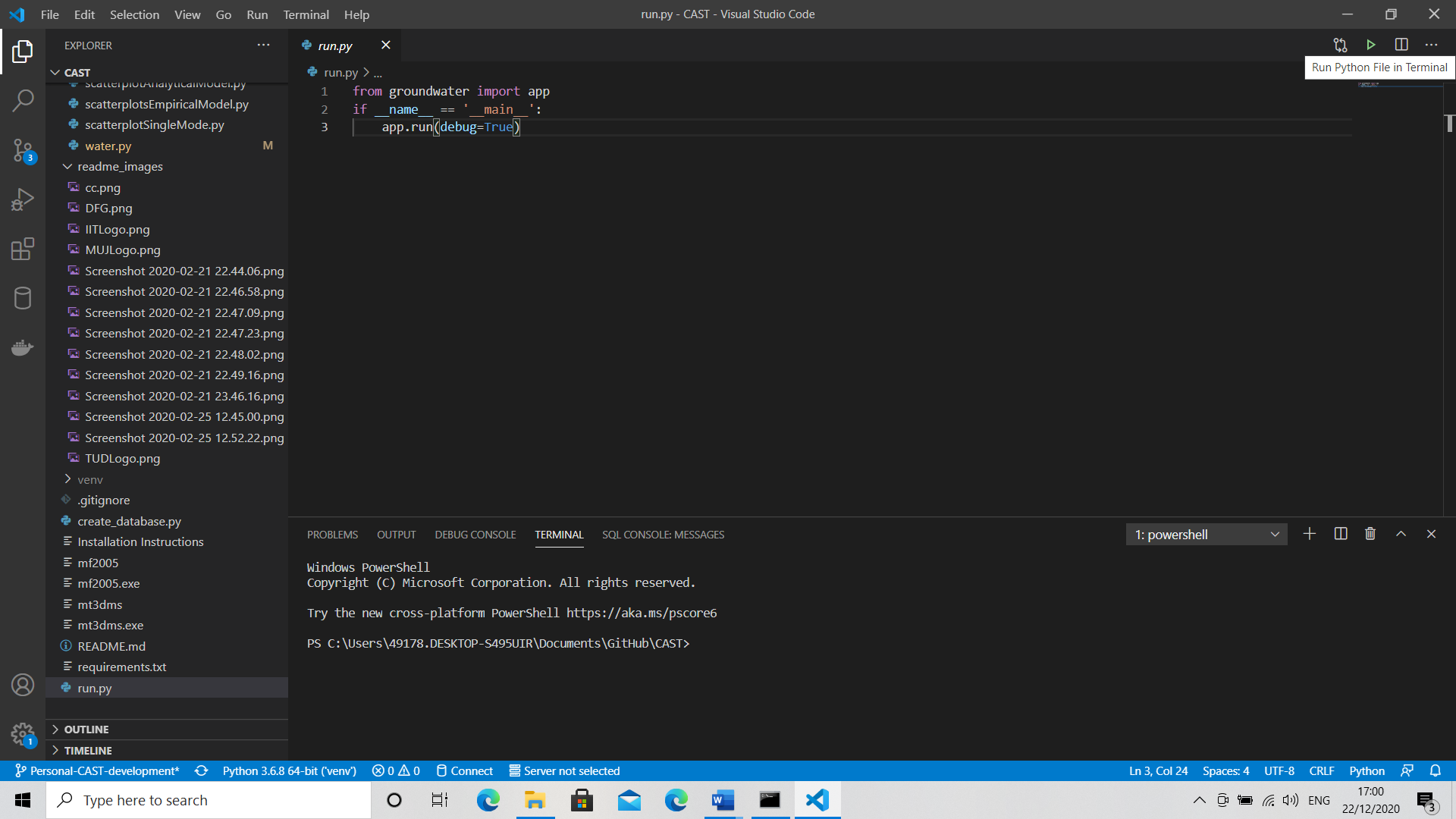

1. Click on the link to get to the CAST Webpage

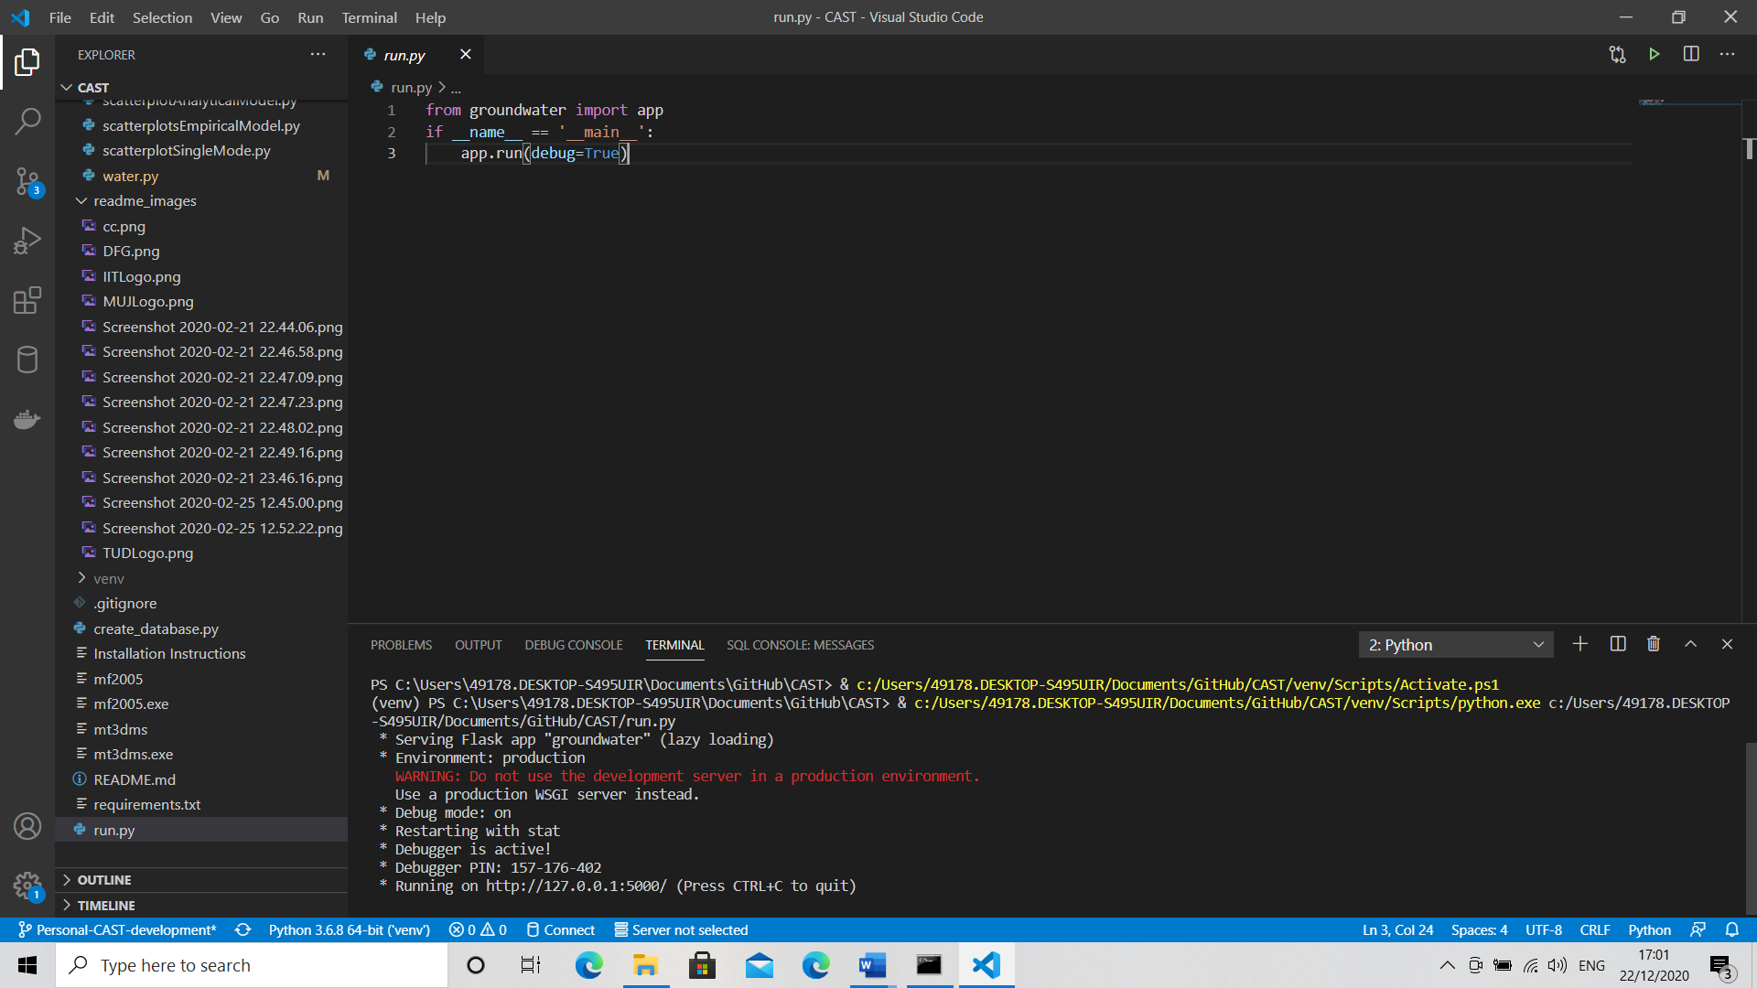

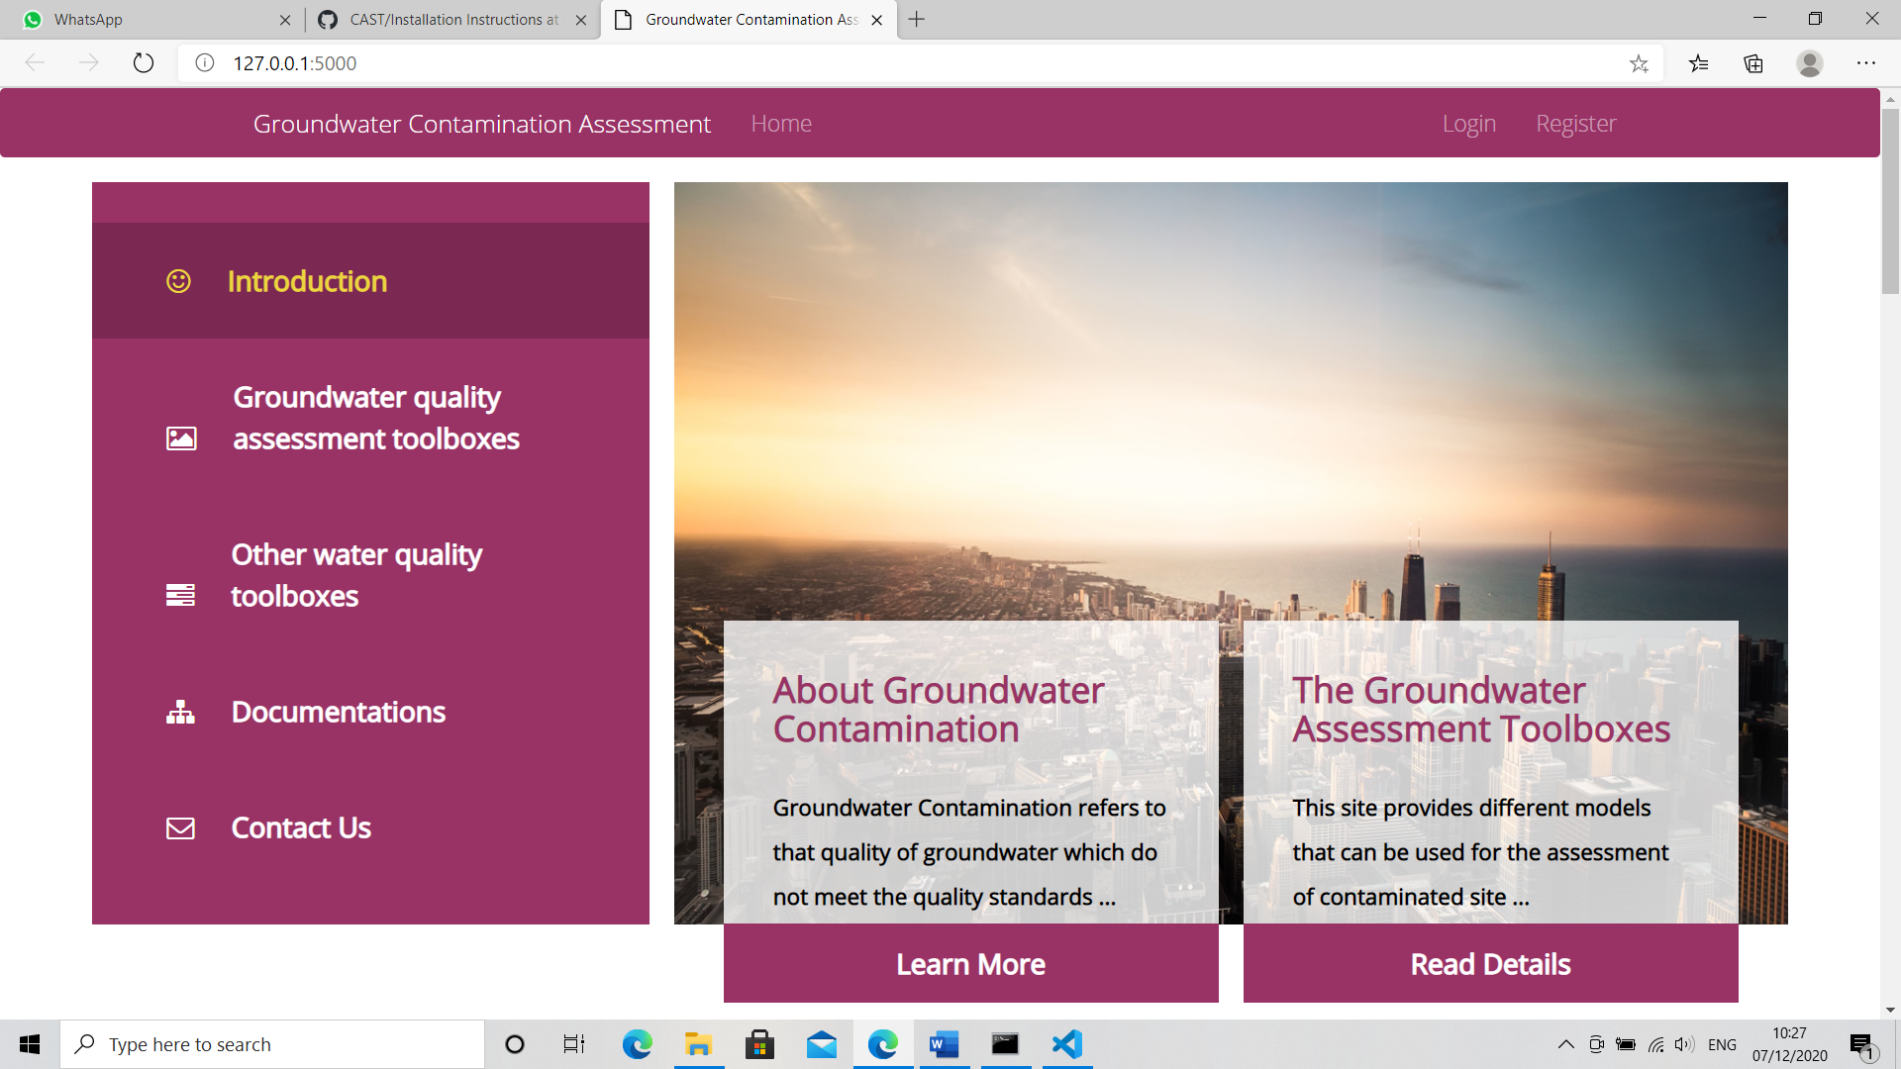

You can log in with your email ID and a password. If you wish to close the server simply Hold **Ctrl+C** to stop the server from running.

From the next time, to run the CAST webpage, all that is required is to open Visual Studio Code and follow from the **Step 16.**